Project Development Phase
Performance Test

Date | 12 September 2026
Project Name | Employee Raise Issue
Maximum Marks

Model Performance Testing:
Project developer has completed the following information in the Model Performance Testing Template.
S.No. | Parameter | Screenshot / Values
 | Data Rendered | 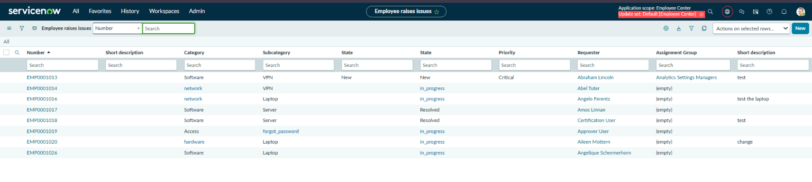
 | Data Preprocessing | 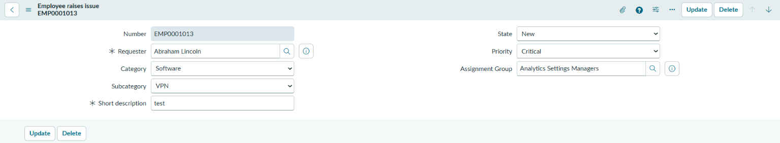
3. | Utilization of Filters | 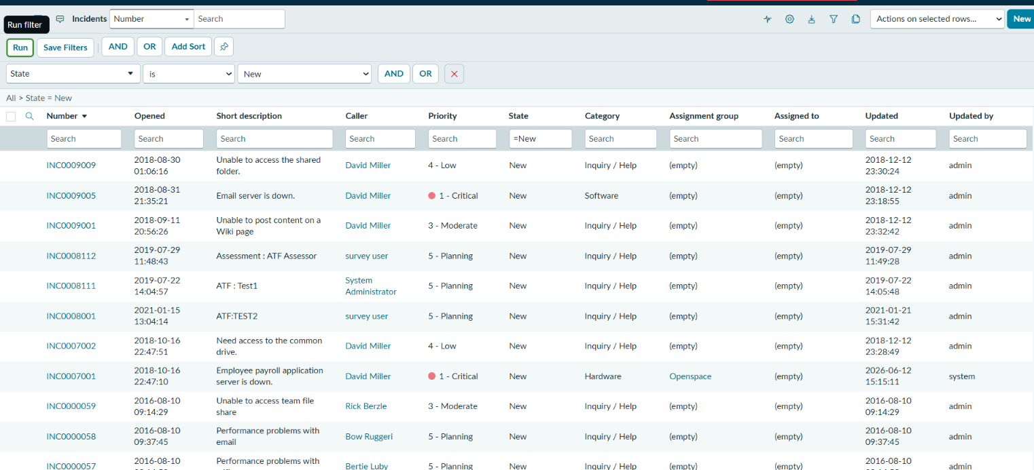
4. | Calculation fields Used | N/A
5. | Dashboard design | Number of Visualizations/Graphs – 0 (N/A
6 | Story Design | Number of Visualizations/Graphs – 0 (N/A

